Hashing Projects
- Fun With Chemistry

You are to write a class that maintains information on various chemical compounds. For any compound you need the following information:

ID
Bonding (Ionic or Covalent) metal/non-metal , metal
Molecular Weight
Density
Solubility (in water) sol, non sol, slightly sol

For Example, the compound Sodium Chloride has the following:

ID NaCl
Bonding Ionic
Mol Wt 58.5 g
Den 1.54 g/ml
Sol YES

Make sure you have several compounds to add. Examples are:

Water H2O
Carbon Dioxide CO2
Hydrochloric Acid HCL
Glucose C6H12O6

:A. Identify the part of the Compound Class that you will use as the KEY Populate your hashMap with several Compounds
(Use the Integer or String class as the Key Value AND
the Compound class instance as the value object)

B. Display the number of key / value pairs in the Map

C. Ask the user for a Compound and determine if the Key maps to a
Compound in the Map

D. Create a HashSet of the keys in the Map and iterate over the keys
USING the keys to get the values in the map. Iterate Using the ITERATOR and THEN Using the FOR EACH LOOP.

E. Put a new key / value pair into the HashMap with an existing key but
a different value object THEN display the pairs in the Map & the
new pair ‘s value object should replace the original value object
(IE. Change a property of one of the compounds)

2. POE

We have implemented POE as an ArrayList a LinkedList and now we will
implement POE using Hashing

If you implemented POE as an array of Linked Lists, you could have searched
if a given word was unique by taking the first letter and matching that to an array index

You could then traverse that smaller list and if no node contains the word, you add it to the list , otherwise you add 1 to a counter

Example:

array index letter list

0 a Amontillado

19 t the this

This is a good step, but as N grows, the approach of creating 26 smaller lists
still approaches O(n)

The true solution is to create a hash table of unique words

With a hash table, we can select the specific “word” on constant time O(1)

You may use the HashSet or HashMap to implement your POE data structure of unique words

You must produce the number of unique words and the most frequent word
as well as the ability to determine if a given word exists and how many times it occurs in the story

3. GridWorld Case Study Lab

The GridWorld Case Study is detailed in the PDF file:

Grid World Narrative.pdf , which can be found on the AP page in the “Grid World Case Study” link.

READ the following sections of the NARRATIVE :

PART 3 page 15 --- Grid World Classes and Interfaces

This deals with the interactions and class relationships between the
Location class, Actor Class (bugs) and the Grid (bounded, unbounded
Environment)

Make sure you UNDERSTAND the relationships between the parts of
The GridWorld (Actor and children, Grid Interface and its users, Location)

PART 5 page 35 --- Grid Data Structures **** SEE IMPLEMENTATION NOTE THAT AT END OF THIS DOCUMENT

This deals with Grid, AbstractedGrid, Bounded and UnBounded Grids.

Again, Make sure you UNDERSTAND these relationships and the role
Of the “World” class.

- DO QUESTIONS 1 and 3 on pages 38

- DO Exercises 2 and 3 on page 40. However, exercise #2 asks you to
CONSIDER implementing a HashMap. YOU are REQUIRED to IMPLEMENT the SparseBoundedGrid with a HashMap.

*** IMPLEMENTATION NOTE FOR EXERCISE 2:

All of the grid, location, actor, world and environment classes for this case study are compiled and packaged in the gridworld.jar file which you already added in your libraries when you completed the summer assignment.

You can view the SOURCE code for these classes in the following directory:

GW Code\GridWorldCode\framework\info\gridworld
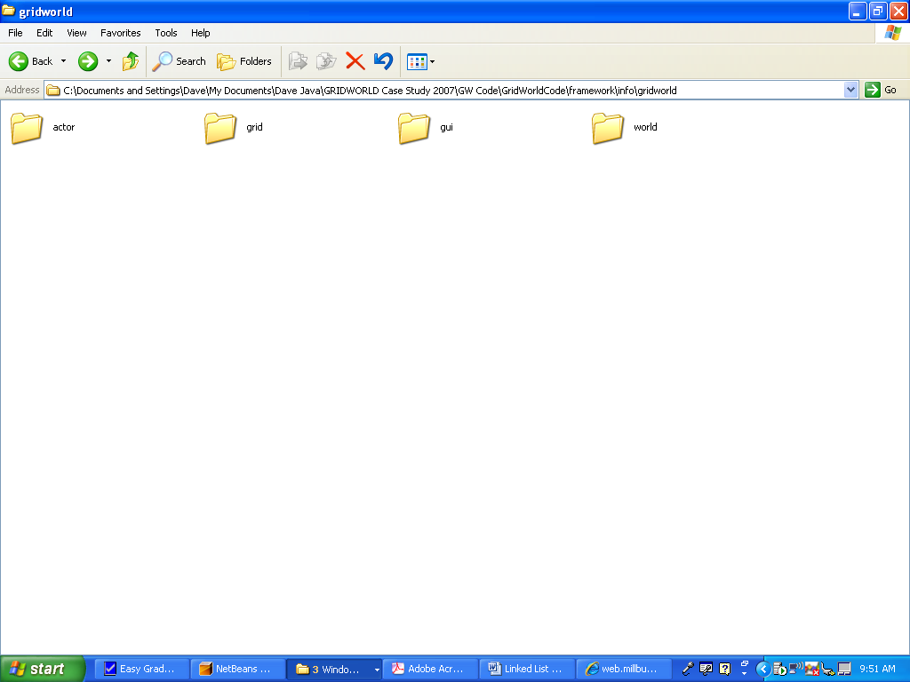

TO view specific class code, go into the appropriate folder:

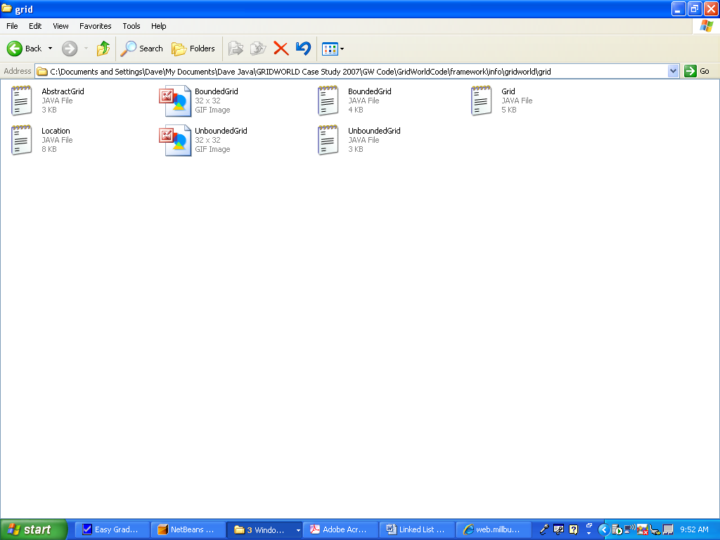

You can then “copy” an existing grid environment (bounded or unbounded) , rename the class and copy it into your existing GW project. Then modify it to execute as a sparse matrix utilizing Linked Lists.

You will have to adjust the imports and comment out the package as this class was originally looking into the jar files for supporting classes:

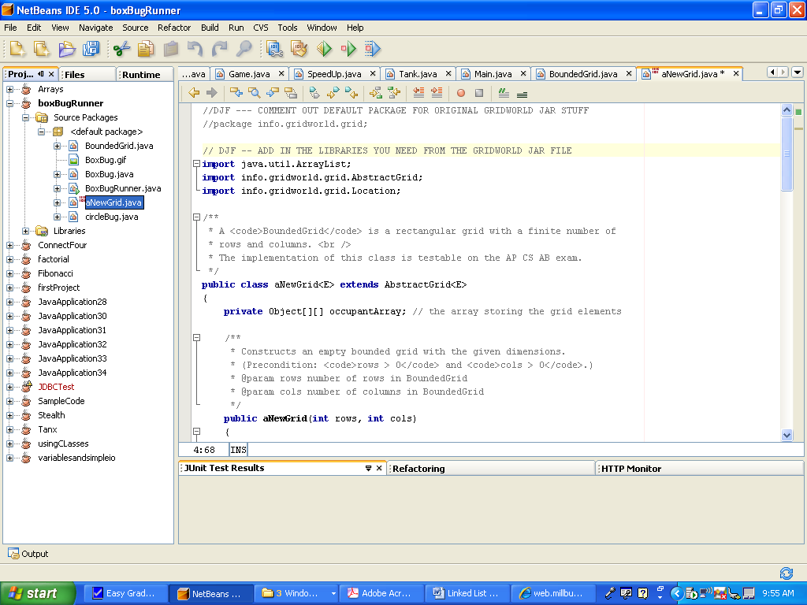

Finally, add the environment to the world by adding the class in your driver:

